UNITED STATES

SECURITIES AND EXCHANGE COMMISSION

Washington, D.C. 20549

SCHEDULE 14A

(Rule 14a-101)

INFORMATION REQUIRED IN PROXY STATEMENT

SCHEDULE 14A INFORMATION

Proxy Statement Pursuant to Section 14(a) of The Securities Exchange Act of 1934

(Amendment No. )

Filed by the Registrant ☐

Filed by a Party other than the Registrant ☒

Check the appropriate box:

- Preliminary Proxy Statement

- Confidential, for Use of the Commission Only (as permitted by Rule 14a-6(e)(2))

- Definitive Proxy Statement

- Definitive Additional Materials

- Soliciting Material Under Rule 14a-12

HASBRO, INC.

(Name of Registrant as Specified in Its Charter)

ALTA FOX OPPORTUNITIES FUND, LP

ALTA FOX SPV 3, LP

ALTA FOX SPV 3.1, LP

ALTA FOX GENPAR, LP

ALTA FOX EQUITY, LLC

ALTA FOX CAPITAL MANAGEMENT, LLC

CONNOR HALEY

MATTHEW CALKINS

JON FINKEL

MARCELO FISCHER

RANI HUBLOU

CAROLYN JOHNSON
(Name of Persons(s) Filing Proxy Statement, if Other Than the Registrant)

Payment of Filing Fee (Check the appropriate box):

- No fee required.

- Fee computed on table below per Exchange Act Rules 14a-6(i)(1) and 0-11.

- Title of each class of securities to which transaction applies:

- Aggregate number of securities to which transaction applies:

- Per unit price or other underlying value of transaction computed pursuant to Exchange Act Rule 0-11 (set forth the amount on which the filing fee is calculated and state how it was determined):

- Proposed maximum aggregate value of transaction:

- Total fee paid:

- Fee paid previously with preliminary materials:

- Check box if any part of the fee is offset as provided by Exchange Act Rule 0-11(a)(2) and identify the filing for which the offsetting fee was paid previously. Identify the previous filing by registration statement number, or the form or schedule and the date of its filing.

- Amount previously paid:

- Form, Schedule or Registration Statement No.:

- Filing Party:

- Date Filed:

Alta Fox Opportunities Fund, LP, together with the other participants named herein (collectively, “Alta Fox”), intends to file a preliminary proxy statement and accompanying GOLD proxy card with the Securities and Exchange Commission to be used to solicit votes for the election of its slate of highly-qualified director nominees at the 2022 annual meeting of shareholders of Hasbro, Inc., a Rhode Island corporation (the “Company”).

Item 1: On February 25, 2022, Connor Haley, Managing Partner of Alta Fox Opportunities Fund, LP was quoted in the following article published by Bloomberg:

Activist Behind Hasbro Spinoff Push Is a Gamer With Gripes

Bloomberg

By Mary Biekert and Max Reyes

February 25, 2022

- Proxy battle is calling attention to Wizards of the Coast unit

- Fast-growing division accounts for more than half of profit

Connor Haley has been playing the Magic: The Gathering card game for most of his life. Now, the 31-year-old is trying to lead his fellow gamers on a corporate revolt.

Haley’s Alta Fox Capital Management is pushing for Hasbro Inc. to spin off its lucrative Wizards of the Coast division, which includes Magic: The Gathering as well as the Dungeons & Dragons role-playing game. The Wizards unit was one of the toy giant’s best performers in 2021, with revenue rising 42% to $1.29 billion. Haley thinks it’s undervalued within the larger Hasbro enterprise.

“These are amazing timeless brands with maniacal fans,” Haley said in an interview. “I think we’ve really tapped into these communities and tried to understand the frustrations.”

Magic: The Gathering devotees have long complained about Hasbro’s handling of the strategy card game, where players use creatures and spells to vanquish opponents. The gripes range from the number and strength of new cards being released to the quality of paper they’re printed on and the design of online versions.

Those frustrations migrated from Reddit forums and Discord chat rooms to financial markets last week when Haley nominated five new board members and called for restructuring the largest U.S.-based toymaker.

Haley says his Fort Worth, Texas-based investment firm, Alta Fox Capital, owns about 2.5% of Hasbro’s shares. His director nominees include Matt Calkins, a game collector who is also the billionaire founder of software firm Appian Corp., as well as Jon Finkel, one of the top Magic: The Gathering players.

Skeptical Analysts

Many Wall Street analysts are skeptical about Haley’s spinoff plan and its likelihood of success. However, they agree that attention is long overdue for Wizards of the Coast and Hasbro’s fast-growing digital-gaming division. The former head of that business, Chris Cocks, takes over as chief executive officer of the whole company on Friday.

“Alta Fox just shined a very bright light on” Wizards of the Coast, “essentially giving a gift to Chris Cocks,” wrote KeyBanc Capital Markets analyst Brett Andress in a Feb. 17 research note. The focus on the Wizards segment “won’t go away anytime soon,” Andress said.

Hasbro declined to comment about the Alta Fox proxy fight beyond a statement last week confirming that it received the director nominations and has had discussions with the firm. “The board and management team believe Hasbro is on the right path to deliver sustainable growth for shareholders,” the company said.

Before being acquired by Hasbro for about $325 million in 1999, Wizards of the Coast was an independent game publisher. The business still mostly operates out of Seattle where it was founded, separate from Hasbro’s Rhode Island headquarters. Until last year, investors didn’t know exactly how well the business performed because Hasbro included the results in several geographic segments. Wizards accounted for about 20% of Hasbro’s sales last year but more than half of its profit.

Haley founded Alta Fox in 2018 after working at Scopia Capital Management, a New York-based alternative asset management firm. Alta Fox has since invested in other gaming-related companies, Enlabs AB and Collectors Universe Inc., both of which were acquired. Haley said he’s raised $300 million for his Hasbro stake. One of those investors was EnTrust Global, the investment firm run by Gregg Hymowitz.

“We believe we have massive optionality in this activist investment,” Hymowitz said in a phone interview. “Either we get the board seats and win that way, or we continue to highlight the value opportunity and growth opportunities,” within the Wizards segment.

“Either way we win,” he said.

Gamer Ideas

Having played Magic: The Gathering for more than two decades, Haley said he has long had ideas for how Hasbro could better manage the game. He surveyed gamers before pitching his plan to investors. He heard frustrations around how the company releases new cards, which players argue disrupt the value of older ones. They also complained about the rising price of certain card packs and how the company has run a video game called Magic: The Gathering Arena.

Hasbro released the desktop version of that game in 2019, followed by a mobile one last year. That’s helped attract a new wave of players previously deterred by Magic’s steep learning curve. Like other free-to-play mobile titles, players can buy cards and other items in the game, which has contributed to the big rise in the Wizards division’s sales.

Consumers play Arena an average of nine hours per week, according to Hasbro. But fans say the digital version has issues as well. They’d like to see Hasbro offer more tournaments and a multiplayer option.

“Arena is super anti-consumer,” said Vince Chandler, a YouTube star and one of Magic’s most well-known personalities who goes by PleasantKenobi. “They are making so much money they don’t care.”

Jim Silver, who runs a toy-review website called Toys, Tots, Pets & More, or TTPM, said “it is a vocal minority that’s not happy” with how Hasbro is running the Wizards business. “With their growth and with their profits, why do you want to take that out of the Hasbro portfolio?”

Hasbro has said the division is part of a larger strategy employed by former CEO Brian Goldner, who died last year. The company is looking to extend well-known brands into other categories such as video games, TV shows and films. A Magic: The Gathering TV series is being released on Netflix later this year, and a Dungeons & Dragons film is slated for 2023.

Haley says the formula has led to some disappointing video games and films as well as buying TV show producer Entertainment One for about $4 billion in 2019. That has diminished shareholder value, he said.

“If Hasbro and Wizards want to fully succeed in the long run, they need to make sure that their players are happy,” Haley said. “And they need to embrace the ideas of their players and listen to feedback and respond to that with action.”

Item 2: Also on February 25, 2022, Alta Fox sent the following email to subscribers of www.FreeTheWizards.com:


Fellow Hasbro Stakeholder,

Thank you for your interest in our quest to repair Hasbro and unlock the full potential of Wizards of the Coast.

As you may know, Alta Fox has nominated five highly qualified and independent candidates to Hasbro’s Board of Directors to bring value-enhancing ideas that we believe can improve the customer experience, simplify the corporate structure and drive value for all stakeholders.

We look forward to engaging with you and sharing additional updates in the weeks to come. As a reminder, you can visit www.FreeTheWizards.comto learn more about who we are, review the case for change at Hasbro and share your thoughts.

In the meantime, we wanted to share the below article that ran in Bloomberg today:

Activist Behind Hasbro Spinoff Push Is a Gamer With Gripes

Bloomberg

By Mary Biekert and Max Reyes

February 25, 2022

- Proxy battle is calling attention to Wizards of the Coast unit

- Fast-growing division accounts for more than half of profit

Connor Haley has been playing the Magic: The Gathering card game for most of his life. Now, the 31-year-old is trying to lead his fellow gamers on a corporate revolt.

Haley’s Alta Fox Capital Management is pushing for Hasbro Inc. to spin off its lucrative Wizards of the Coast division, which includes Magic: The Gathering as well as the Dungeons & Dragons role-playing game. The Wizards unit was one of the toy giant’s best performers in 2021, with revenue rising 42% to $1.29 billion. Haley thinks it’s undervalued within the larger Hasbro enterprise.

“These are amazing timeless brands with maniacal fans,” Haley said in an interview. “I think we’ve really tapped into these communities and tried to understand the frustrations.”

Magic: The Gathering devotees have long complained about Hasbro’s handling of the strategy card game, where players use creatures and spells to vanquish opponents. The gripes range from the number and strength of new cards being released to the quality of paper they’re printed on and the design of online versions.

Those frustrations migrated from Reddit forums and Discord chat rooms to financial markets last week when Haley nominated five new board members and called for restructuring the largest U.S.-based toymaker.

Haley says his Fort Worth, Texas-based investment firm, Alta Fox Capital, owns about 2.5% of Hasbro’s shares. His director nominees include Matt Calkins, a game collector who is also the billionaire founder of software firm Appian Corp., as well as Jon Finkel, one of the top Magic: The Gathering players.

Skeptical Analysts

Many Wall Street analysts are skeptical about Haley’s spinoff plan and its likelihood of success. However, they agree that attention is long overdue for Wizards of the Coast and Hasbro’s fast-growing digital-gaming division. The former head of that business, Chris Cocks, takes over as chief executive officer of the whole company on Friday.

“Alta Fox just shined a very bright light on” Wizards of the Coast, “essentially giving a gift to Chris Cocks,” wrote KeyBanc Capital Markets analyst Brett Andress in a Feb. 17 research note. The focus on the Wizards segment “won’t go away anytime soon,” Andress said.

Hasbro declined to comment about the Alta Fox proxy fight beyond a statement last week confirming that it received the director nominations and has had discussions with the firm. “The board and management team believe Hasbro is on the right path to deliver sustainable growth for shareholders,” the company said.

Before being acquired by Hasbro for about $325 million in 1999, Wizards of the Coast was an independent game publisher. The business still mostly operates out of Seattle where it was founded, separate from Hasbro’s Rhode Island headquarters. Until last year, investors didn’t know exactly how well the business performed because Hasbro included the results in several geographic segments. Wizards accounted for about 20% of Hasbro’s sales last year but more than half of its profit.

Haley founded Alta Fox in 2018 after working at Scopia Capital Management, a New York-based alternative asset management firm. Alta Fox has since invested in other gaming-related companies, Enlabs AB and Collectors Universe Inc., both of which were acquired. Haley said he’s raised $300 million for his Hasbro stake. One of those investors was EnTrust Global, the investment firm run by Gregg Hymowitz.

“We believe we have massive optionality in this activist investment,” Hymowitz said in a phone interview. “Either we get the board seats and win that way, or we continue to highlight the value opportunity and growth opportunities,” within the Wizards segment.

“Either way we win,” he said.

Gamer Ideas

Having played Magic: The Gathering for more than two decades, Haley said he has long had ideas for how Hasbro could better manage the game. He surveyed gamers before pitching his plan to investors. He heard frustrations around how the company releases new cards, which players argue disrupt the value of older ones. They also complained about the rising price of certain card packs and how the company has run a video game called Magic: The Gathering Arena.

Hasbro released the desktop version of that game in 2019, followed by a mobile one last year. That’s helped attract a new wave of players previously deterred by Magic’s steep learning curve. Like other free-to-play mobile titles, players can buy cards and other items in the game, which has contributed to the big rise in the Wizards division’s sales.

Consumers play Arena an average of nine hours per week, according to Hasbro. But fans say the digital version has issues as well. They’d like to see Hasbro offer more tournaments and a multiplayer option.

“Arena is super anti-consumer,” said Vince Chandler, a YouTube star and one of Magic’s most well-known personalities who goes by PleasantKenobi. “They are making so much money they don’t care.”

Jim Silver, who runs a toy-review website called Toys, Tots, Pets & More, or TTPM, said “it is a vocal minority that’s not happy” with how Hasbro is running the Wizards business. “With their growth and with their profits, why do you want to take that out of the Hasbro portfolio?”

Hasbro has said the division is part of a larger strategy employed by former CEO Brian Goldner, who died last year. The company is looking to extend well-known brands into other categories such as video games, TV shows and films. A Magic: The Gathering TV series is being released on Netflix later this year, and a Dungeons & Dragons film is slated for 2023.

Haley says the formula has led to some disappointing video games and films as well as buying TV show producer Entertainment One for about $4 billion in 2019. That has diminished shareholder value, he said.

“If Hasbro and Wizards want to fully succeed in the long run, they need to make sure that their players are happy,” Haley said. “And they need to embrace the ideas of their players and listen to feedback and respond to that with action.”

***

Thank you again for your interest and support.

Sincerely,

Connor Haley

Alta Fox Capital Management, LLC

Please see the full disclaimer here.


Copyright © 2022 Alta Fox Capital Management, All rights reserved.

Item 3: Also on February 25, 2022, Alta Fox uploaded the following materials to www.FreeTheWizards.com:
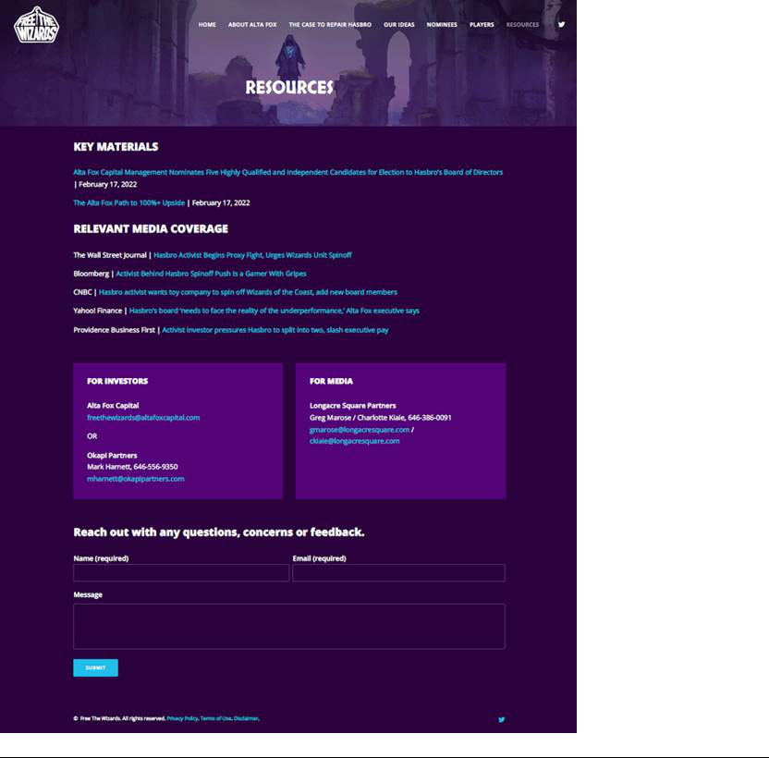

Item 4: On February 22, 2022, members of Alta Fox issued the following statements via social media:

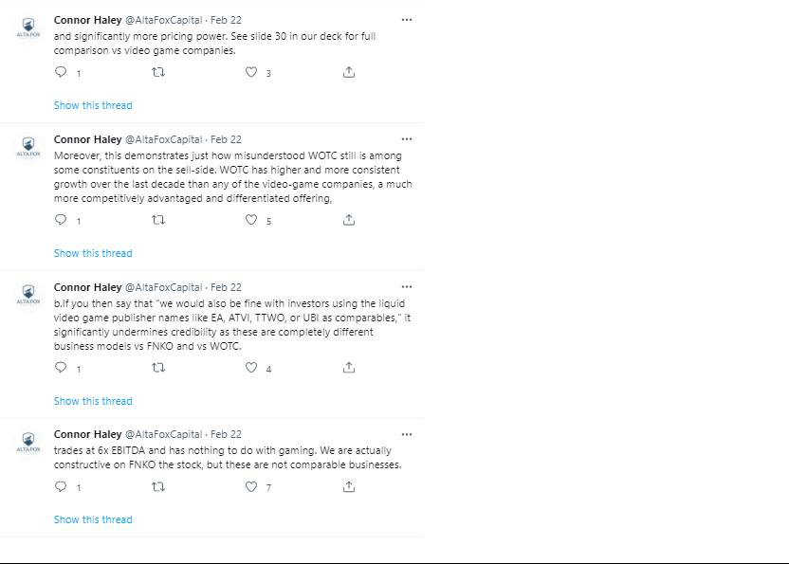

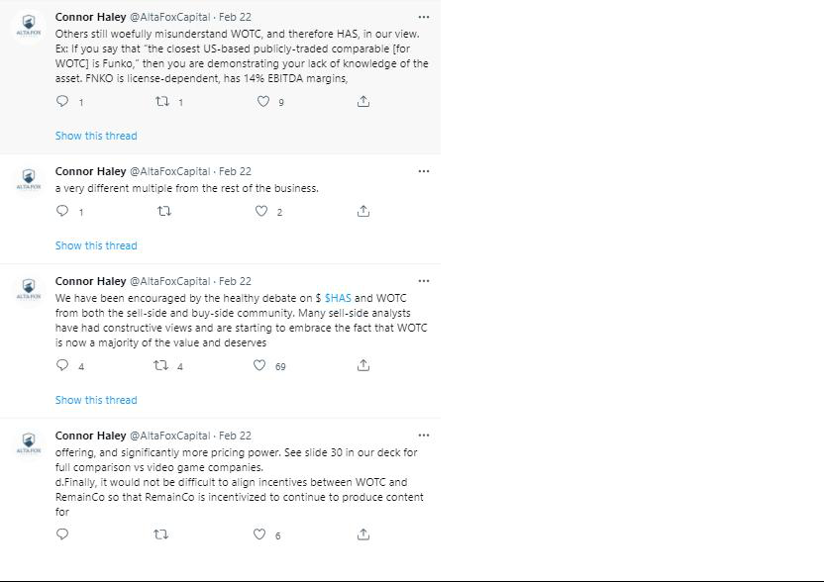

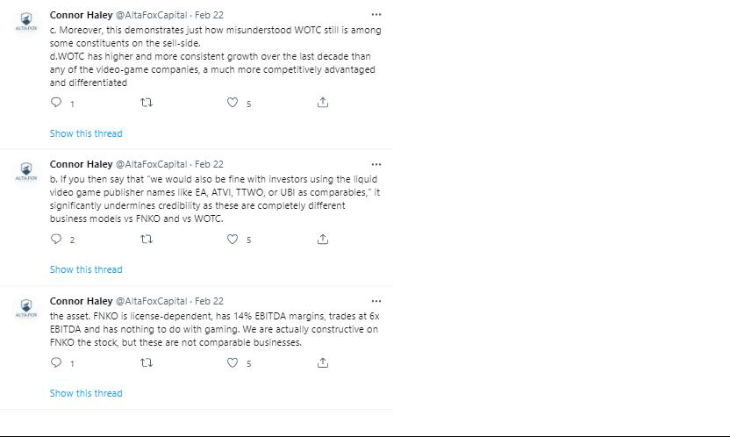

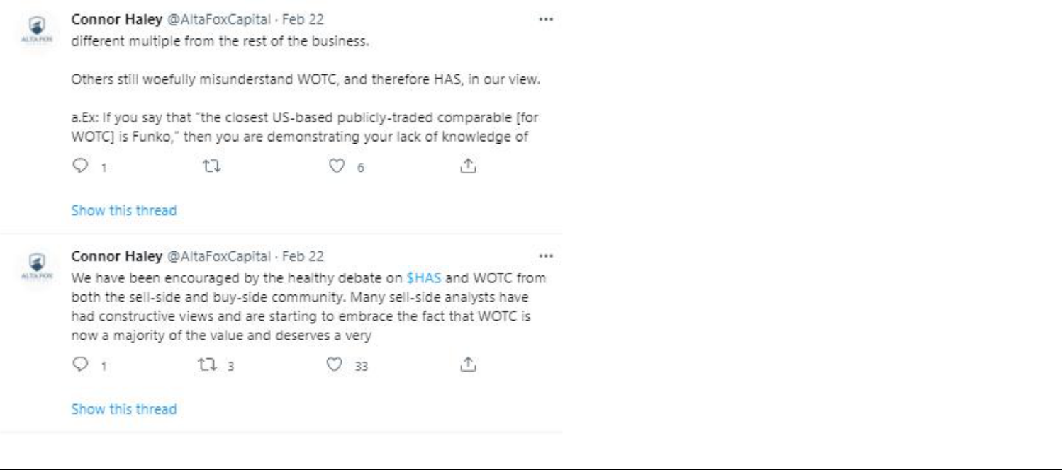

Certain Information Concerning the Participants

Alta Fox Opportunities Fund, LP (“Alta Fox Opportunities”), together with the other participants named herein (collectively, “Alta Fox”), intends to file a preliminary proxy statement and an accompanying GOLD proxy card with the Securities and Exchange Commission (“SEC”) to be used to solicit votes for the election of its slate of highly-qualified director nominees at the 2022 annual meeting of shareholders of Hasbro, Inc., a Rhode Island corporation (the “Company”).

ALTA FOX STRONGLY ADVISES ALL SHAREHOLDERS OF THE COMPANY TO READ THE PROXY STATEMENT AND OTHER PROXY MATERIALS, INCLUDING A GOLD PROXY CARD, AS THEY BECOME AVAILABLE BECAUSE THEY WILL CONTAIN IMPORTANT INFORMATION. SUCH PROXY MATERIALS WILL BE AVAILABLE AT NO CHARGE ON THE SEC’S WEB SITE AT HTTP://WWW.SEC.GOV. IN ADDITION, THE PARTICIPANTS IN THIS PROXY SOLICITATION WILL PROVIDE COPIES OF THE PROXY STATEMENT WITHOUT CHARGE, WHEN AVAILABLE, UPON REQUEST. REQUESTS FOR COPIES SHOULD BE DIRECTED TO THE PARTICIPANTS’ PROXY SOLICITOR.

The participants in the proxy solicitation are expected to be Alta Fox Opportunities, Alta Fox SPV 3, LP (“Alta Fox SPV 3”), Alta Fox SPV 3.1, LP (“Alta Fox SPV 3.1”), Alta Fox GenPar, LP (“Alta Fox GP”), Alta Fox Equity, LLC (“Alta Fox Equity”), Alta Fox Capital Management, LLC (“Alta Fox Capital”), Connor Haley, Matthew Calkins, Jon Finkel, Marcelo Fischer, Rani Hublou and Carolyn Johnson (collectively, the “Participants”).

As of the date hereof, Alta Fox Opportunities directly beneficially owned 962,614 shares of Common Stock, $0.50 par value (the “Common Stock”), of the Company, including 350,000 shares of Common Stock underlying listed call options. As of the date hereof, Alta Fox SPV 3 directly beneficially owned 2,250,138 shares of Common Stock. As of the date hereof, Alta Fox SPV 3.1 directly beneficially owned 748,881 shares of Common Stock. Alta Fox Capital, as the investment manager of each of Alta Fox, Alta Fox SPV 3 and Alta Fox SPV 3.1, may be deemed to beneficially own the 3,961,633 shares of Common Stock beneficially owned in the aggregate by Alta Fox, Alta Fox SPV 3 and Alta Fox SPV 3.1. Alta Fox GP, as the general partner of each of Alta Fox, Alta Fox SPV 3 and Alta Fox SPV 3.1, may be deemed to beneficially own the 3,961,633 shares of Common Stock beneficially owned in the aggregate by Alta Fox, Alta Fox SPV 3 and Alta Fox SPV 3.1. Alta Fox Equity, as the general partner of Alta Fox GP, may be deemed to beneficially own the 3,961,633 shares of Common Stock beneficially owned in the aggregate by Alta Fox, Alta Fox SPV 3 and Alta Fox SPV 3.1. Mr. Haley, as the sole owner, member and manager of each of Alta Fox Capital and Alta Fox Equity, may be deemed to beneficially own the 3,961,633 shares of Common Stock beneficially owned in the aggregate by Alta Fox, Alta Fox SPV 3 and Alta Fox SPV 3.1. As of the date hereof, Mr. Calkins directly beneficially owned 51,495 shares of Common Stock. As of the date hereof, Mr. Fischer directly beneficially owned 5,327 shares of Common Stock. As of the date hereof, Ms. Johnson directly beneficially owned 500 shares of Common Stock. As of the date hereof, none of Mr. Finkel nor Ms. Hublou beneficially owned any shares of Common Stock.

