SCHEDULE 14A INFORMATION

PROXY STATEMENT PURSUANT TO SECTION 14(a) OF THE SECURITIES

EXCHANGE ACT OF 1934 (AMENDMENT NO. )

Filed By The Registrant ☒

Filed By A Party Other Than The Registrant ☐

Check the appropriate box:

- Preliminary Proxy Statement

- Confidential, for Use of the Commission Only (as permitted by Rule 14a-6(e)(2))

- Definitive Proxy Statement

- Definitive Additional Materials

- Soliciting Material Pursuant to sec.240.14a-12

HASBRO, INC.

(Name of Registrant as Specified In Its Charter)

Payment Of Filing Fee (Check The Appropriate Box):

- No fee required.

- Fee computed on table below per Exchange Act Rules 14a-6(i)(1) and 0-11.

  - Title of each class of securities to which transaction applies:

  - Aggregate number of securities to which transaction applies:

  - Per unit price or other underlying value of transaction computed pursuant to Exchange Act Rule 0-11 (Set forth the amount on which the filing fee is calculated and state how it was determined):

  - Proposed maximum aggregate value of transaction:

  - Total fee paid:

- Fee paid previously with preliminary materials.

- Check box if any part of the fee is offset as provided by Exchange Act Rule 0-11(a)(2) and identify the filing for which the offsetting fee was paid previously. Identify the previous filing by registration statement number, or the Form or Schedule and the date of its filing.

  - Amount Previously Paid:

  - Form, Schedule or Registration Statement No.:

  - Filing Party:

  - Date Filed:

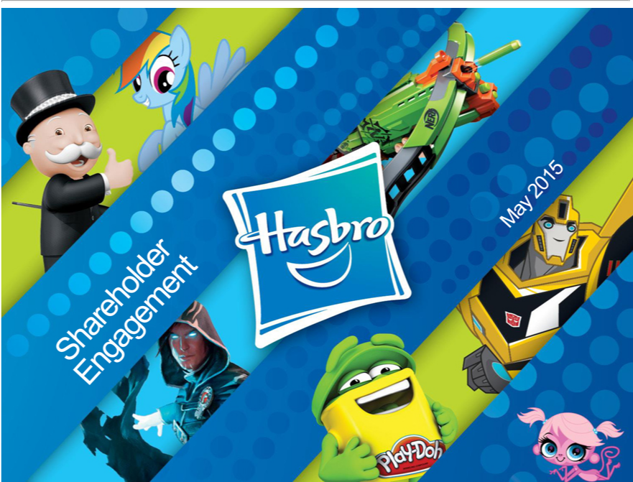

MayShareholder2015 Engagement

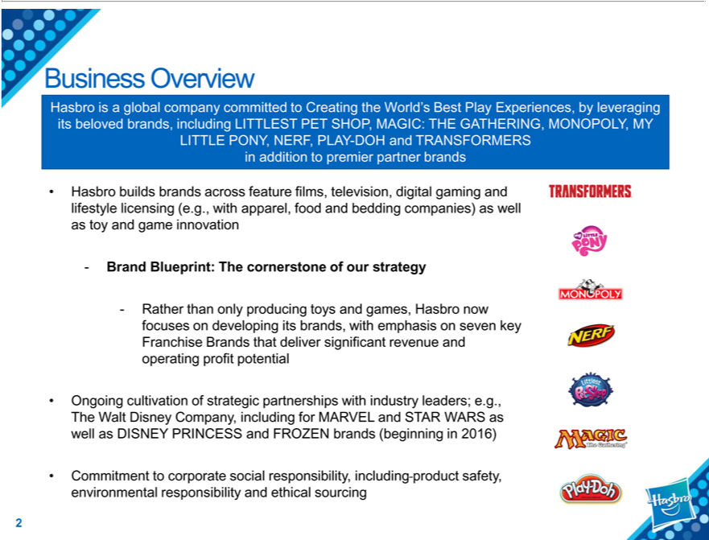

_{Hasbro}Buiness Overview
is a global company committed to Creating the World’s Best Play Experiences, by leveraging its beloved brands, including LITTLEST PET SHOP, MAGIC: THE GATHERING, MONOPOLY, MY LITTLE PONY, NERF, PLAY-DOH and TRANSFORMERS^{gaming}addition to premier partner brands
Hasbro builds brands across feature films, television, digital and lifestyle licensing (e.g., with apparel, food and bedding companies) as well as toy and game innovation ⁻ Brand Blueprint: The cornerstone of our strategy
Rather than only producing toys and games, Hasbro now focuses on developing its brands, with emphasis on seven key Franchise Brands that deliver significant revenue and operating profit potential
2016)Ongoing cultivation of strategic partnerships with industry leaders; e.g., The Walt Disney Company, including for MARVEL and STAR WARS as well as DISNEY PRINCESS and FROZEN brands (beginning in
Commitment to corporate social responsibility, including product safety, environmental responsibility and ethical sourcing 2

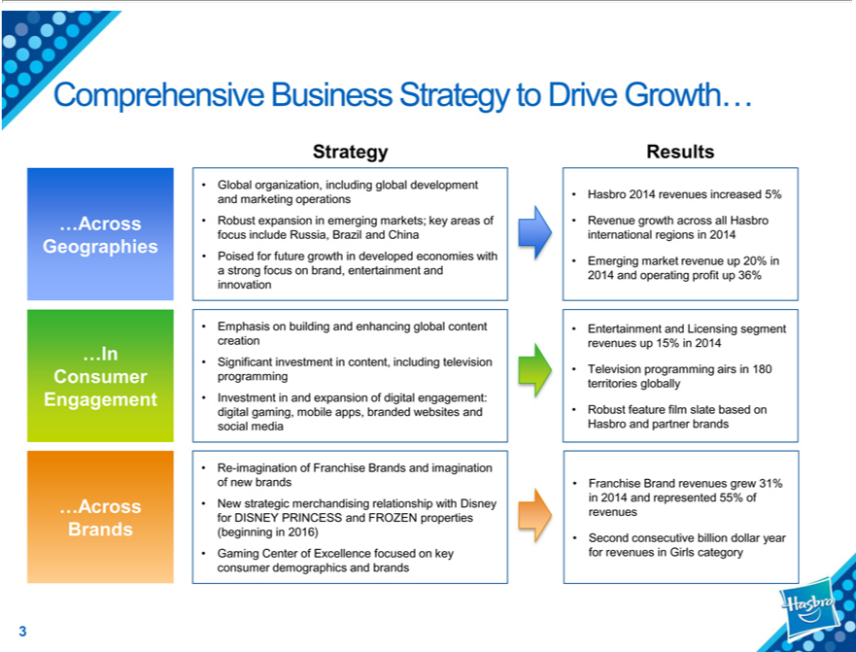

Comprehensive Business Strategy to Drive Growth…
Strategy Results
• Global organization, including global development
and marketing operations • Hasbro 2014 revenues increased 5%
…Across • Robust expansion in emerging markets; key areas of • Revenue growth across all Hasbro
focus include Russia, Brazil and China international regions in 2014
Geographies | developed economies with • Emerging market revenue up 20% in
• Poised for future growth
strong focus on brand, entertainment and 2014 and operating profit up 36%
innovation
• Emphasis on building and enhancing global content • Entertainment and Licensing segment
creation revenues up 15% | 2014
…In • Significant investment in content, including television
Consumer programming • Television programming airs in 180
territories globally
Engagement • Investment in and expansion of digital engagement:
digital gaming, mobile apps, branded websites and • Robust feature film slate based on
social media Hasbro and partner brands
• Re-imagination of Franchise Brands and imagination
of new brands • Franchise Brand revenues grew 31%
…Across • New strategic merchandising relationship with Disney revenues in 2014 and represented 55% of
for DISNEY PRINCESS and FROZEN properties
Brands(beginning in 2016) • Second |  | billion dollar year
consecutive
consumer•Gaming CenterdemographicsofExcellenceandbrandsfocused key for revenues in Girls category

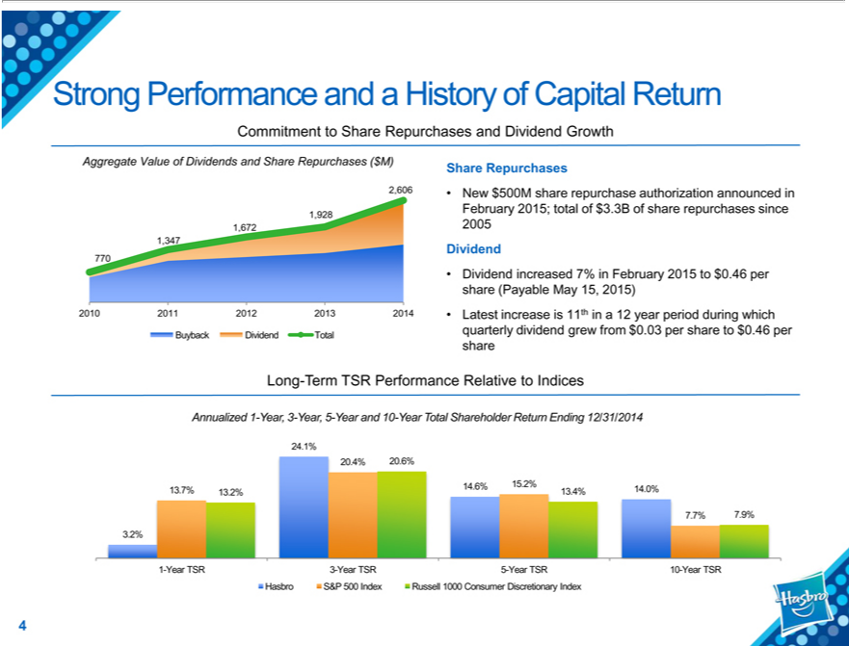

Strong Performance and |  |  | History of Capital Return
Commitment to Share Repurchases and Dividend Growth
Aggregate Value of Dividends and Share Repurchases ($M)
2 606
928
672
1,347
770
2010 2011 2012 2013 2014
Buyback Dividend Total
Share Repurchases
New $500M share repurchase authorization announced in February 2015; total of $3.3B of share repurchases since 2005
Dividend |  | ased 7% in February 2015 to $0.46 per share (Payable May 15, 2015)
atest increase is 11th in |  |  | 12 year period during which quarterly dividend grew from $0.03 per share to $0.46 per share
Long-Term TSR Performance Relative to Indices
Annualized 1-Year, 3-Year, 5-Year and 10-Year Total Shareholder Return Ending 12/31/2014
4 1%
20 4% 20 6%
13.7% | 13.2% 14.6% 15.2% 13.4% 14.0%
7 7% 7.9%
3.2%
1-Year TSR 3-Year TSR 5-Year TSR 10-Year TSR

Hasbro S&P 500 Index Russell 1000 Consumer Discretionary Index

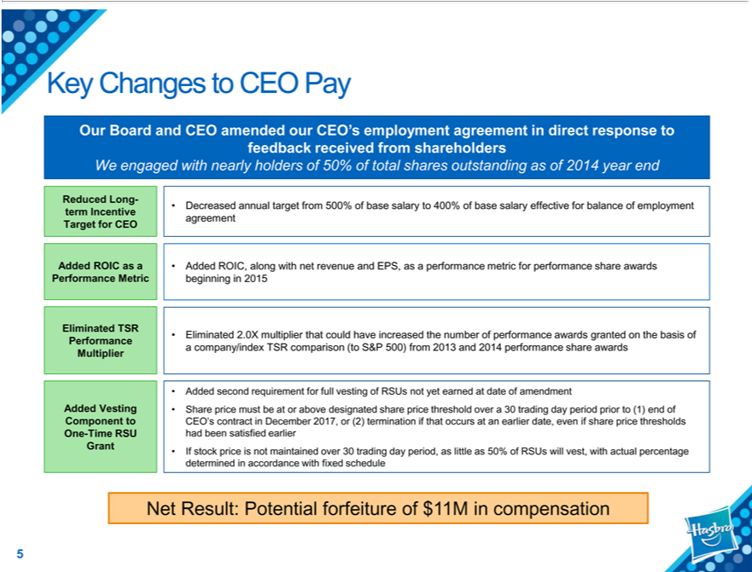

Key Changes to CEO Pay
Our Board and CEO amended our CEO’s employment agreement in direct response to feedback received from shareholders _{Reduced}Wengaged with nearly holders of 50% of total shares outstanding as of 2014 year end
Long- • Decreased annual target from 500% of base salary to 400% of base salary effective for balance of employment term Incentive agreement
Target for CEO
Added ROIC as a • Added ROIC, along with net revenue and EPS, as a performance metric for performance share awards Performance Metric beginning in 2015
Eliminated TSR
_{Performance} • Eliminated 2.0X multiplier that could have increased the number of performance awards granted on the basis of Multiplier company/index TSR comparison (to S&P 500) from 2013 and 2014 performance share awards
• Added second requirement for full vesting of RSUs not yet earned at date of _{amendment}
Added Vesting • Share price must_{December}atorabove designated share price threshold over 30 trading day period prior to (1) end of
Component to CEO’s contract in 2017, or (2) termination if that occurs at an earlier date, even if share price thresholds One-Time RSU had been satisfied earlier
Grant • If stock price is not maintained over 30 trading day period, as little as 50% of RSUs will vest, with actual percentage determined in accordance with fixed schedule
Net Result: Potential forfeiture of $11M in compensation

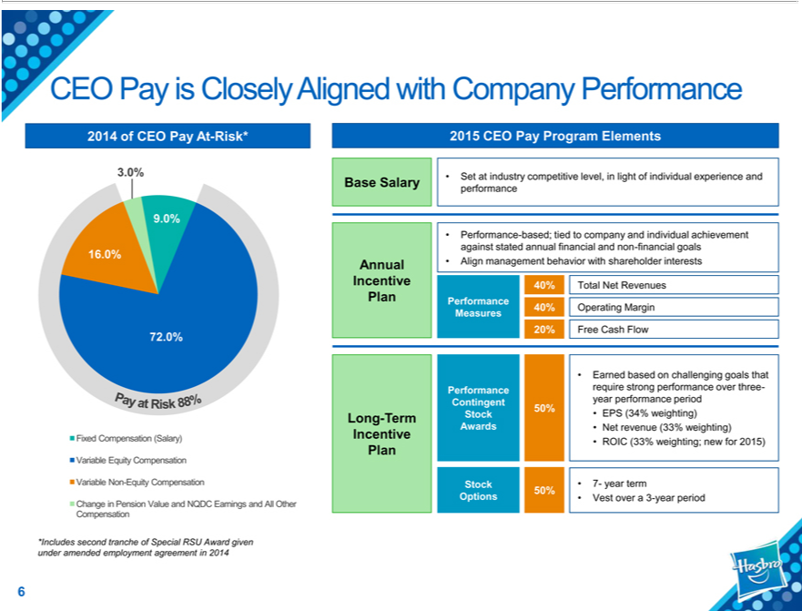

CEO Pay is Closely Aligned with Company Performance
2014 of CEO Pay At-Risk* 2015 CEO Pay Program Elements
9³.0%
¹⁶.0%
72
Fixed Compensation (Salary)
_{Variable} NonEquity-EquityCompensationCompensation
_{Compensation}hangeinPension Value and NQDC Earnings and All Other
und^{Base}*Includesramendedsecondemploymenttrancheof SpecialagreementRSUinAward2014 given
performanceSalary• Set at industry competitive level, in light of individual experience and
against•Performancestatedannual-based;financialtiedtocompanyandnon-andfinancialindividualgoalsachievement
IncentiveAnnual• Align40%TotalmanagementNetRevenuesbehavior with shareholder interests
Plan Performance
20%MeasuresFree 40%Cash OperatingFlow Margin
• Earned based on challenging goals that
ContingentPerformanceyearrequireperformancestrongperformanceperiod over three-
50%
IncentiveLong-TermAwardsStock •• NetEPSrevenue(34%weighting)(33%weighting)
Plan•ROIC (33% weighting; new for 2015)
50%Stock • 7- year term
6Options • Vest over a 3-year period

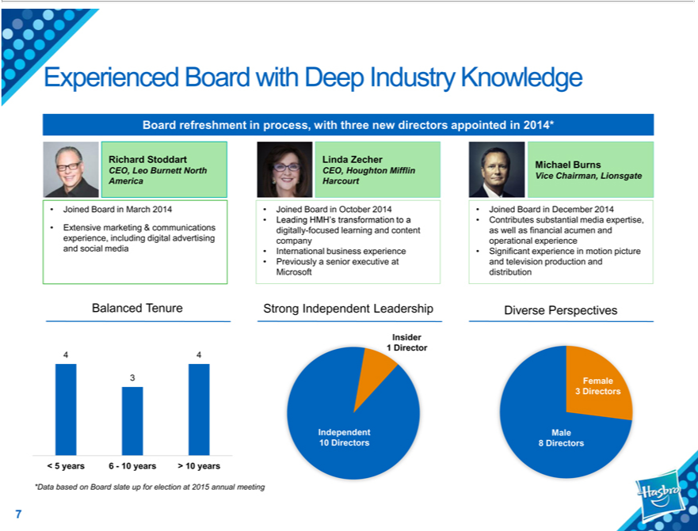

Experienced Board with Deep Industry Knowledge
Board refreshment in process, with three new directors appointed in 2014*
Richard Stoddart
CEO, Leo Burnett North America
Joined Board |  | March 2014
Extensive marketing & communications experience, including digital advertising and social media
Linda Zecher
CEO, Houghton Mifflin Harcourt
Joined Board in October 2014
Leading HMH’ |  | transformation to a digitally-focused learning and content company
 | business experience
InternationalPreviously senior executive at Microsoft
Michael Burns
Vice Chairman, Lionsgate
Joi ed Board in December 2014
Contributes substantial media expertise, as well as financial acumen and operational experience
Significant experience in motion picture and television production and distribution
Balanced Tenure Strong Independent Leadership Diverse Perspectives
Insider
1 Director
4 | 4
3
< 5 years 6—10 years > 10 years
Insider*Databased on Board slate up for election at 2015 annual meeting
Female1Director
Independent3Directors Male
10 Directors 8 Directors

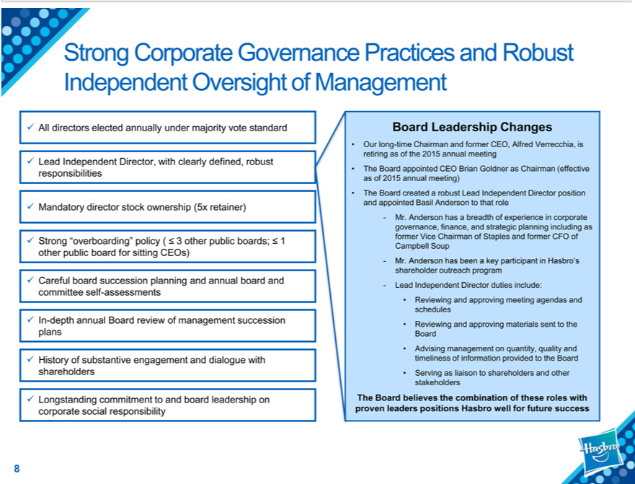

Strong Corporate Governance Practices and Robust Independent Oversight of Management
All directors elected annually under majority vote standard
Lead Independent Director, with clearly defined, robust responsibilities
Mandatory director stock ownership (5x retainer)
Strong | policy ( ? 3 other public boards; ? 1 other public board for sitting CEOs)
Careful“overboarding”succession planning and annual board and committee self-assessments
In-depth annual Board review of management succession plans
History of substantive engagement and dialogue with shareholders
Longstanding commitment to and board leadership on corporate social responsibility
Board Leadership Changes
Our long-time Chairman and former CEO, Alfred Verrecchia, is retiring as of the 2015 annual meeting
 | CEO Brian Goldner as Chairman (effective as of 2015 annual meeting)
The Board created robust Lead Independent Director position and appointed Basil Anderson to that role
appointed | of experience in corporate governance, finance, and strategic planning including as former Vice Chairman of Staples and former CFO of Campbell Soup
⁻ Mr. Anderson has breadth
Lead Independent beenDirectorkeydutiesparticipantinclude:in Hasbro’s shareholder outreach program
Reviewing and approving materials^{eetingagendas}sentto the^{and}Board^{schedules}
Advising management on quantity, quality and timeliness of information provided to the Board
Serving as liaison to shareholders and other stakeholders
The Board believes the combination of these roles with proven leaders positions Hasbro well for future success

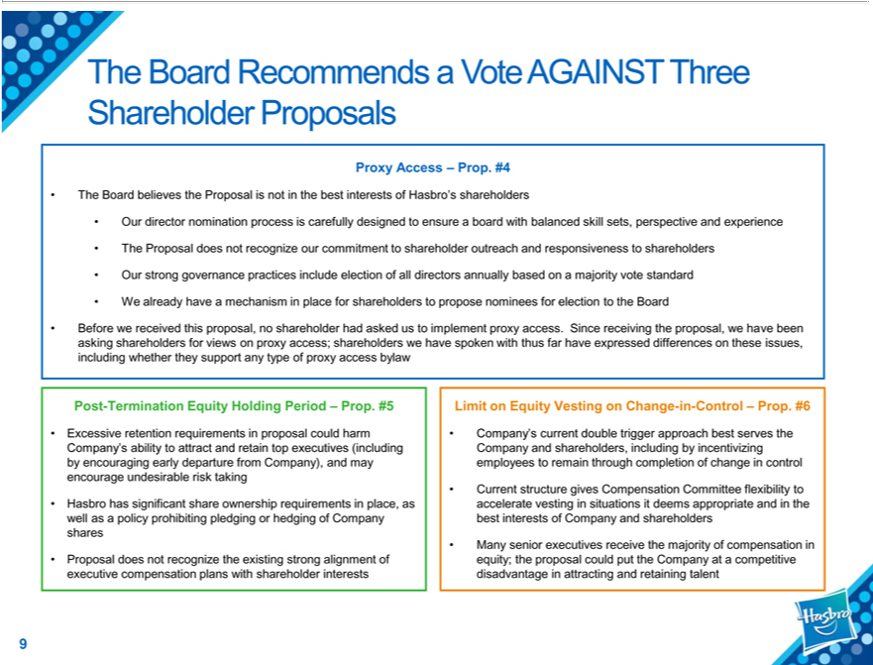

The Board Recommends a Vote AGAINST Three Shareholder Proposals
Proxy Access – Prop. #4 |  |  | s shareholders
The Board believes the Proposal is not in the best interests of
Our director nomination process is carefully designed to ensureHasbro’board with balanced skill sets, perspective and experience
The Proposal does not recognize our commitment to shareholder outreach and |  |  |  |  | to shareholders
Our strong | practices include election of all |  | annually basedresponsivenessamajority vote standard
W already governancehavemechanism in place for shareholdersdirectorspropose nominees for election to the Board
Before we r ceived this proposal, no shareholder had asked us to implement proxy access. Since receiving the proposal, we have been asking shareholders for views on proxy access; shareholders we have spoken with
thus far have expressed differences on these issues, including whether they support any type of proxy access bylaw
Post-Termination Equity Holding Period – Prop. #5
Excessive retention requirements |  | proposal could harm |  | early departure from Company), and may encourage undesirable risk taking
Company’s ability to attract and retain top executives (including by
Hasbro has significant share ownership requirements in place, as wellencouragingaspolicy prohibiting pledging or hedging of Company shares
Proposal does not recognize the |  | strong alignment of executive compensation plans with shareholder interests
Limit on Equity Vesting on Changeexisting--Control – Prop. #6
’s current double trigger approach best serves the
ompany and shareholders, including by incentivizing employees to remain through completion of change in control
Current structure gives Compensation Committee flexibility to accelerate vesting in situations it deems |  |  |  |  |  | and in the best interests of Company and shareholders
Many senior executives receive the majority of compensation in equity; the proposal could put the Companyappropriatecompetitive disadvantage in attracting and retaining talent

Toy & Game
Product
Innovation
Storytelling
Digital Lifestyle
ConsumerMediaBRANDSInsightsLicensing
_{Experiences}Imntertainmentve
Strategic Retail Partnerships

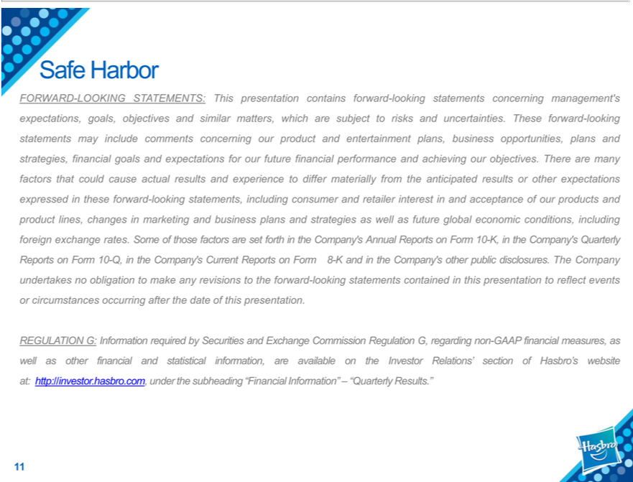

Safe Harbor
uncertainties.FORWARD-LOOKINGTheseforwardSTATEMENTS:-lookingstatementsThispresentationmayincludecontainscommentsforwardconcerning-lookingourstatementsproduct andconcerningentertainmentmanagement’plans,businessexpectations,opportunities,goals,objectivesplansand andstrategies,similarfinancialmatters, whichgoalsandare expectationssubjecttorisksforandour future forwardinancial performance and achieving our objectives. There are many factors that could cause actual results and experience to differ materially from the anticipated results or other expectations expressed in these
-lookingincludstatements,gforeignincludingexchangeconsumerrates.Someandofretailerthose factorsinterestarein setandforthacceptanceintheCompany’ofourproductsAnnualandReportsproduct lines,Formchanges10-K, inin marketingtheCompany’and businessQuarterlyplansReportsand strategiesonForm10as-Q,wellinasthefutureCompany’global economicCurrentReports
conditions,Form8-K and in the Company’s other public disclosures. The Company undertakes no obligation to make any revisions to the forward-looking statements contained in this presentation to reflect events or circumstances occurring after the date of this presentation.

InvestorREGULATIONRelations’G: InformationsectionofHasbro’srequiredwebsitebySecuritiesat:http://investor.hasbro.com,andExchangeCommissionunderRegulationthesubheadingG,regarding“Financialnon-Information”GAAPfinancial–“Quarterlymeasures,Results.”aswellas other financial and statistical information, are available on the

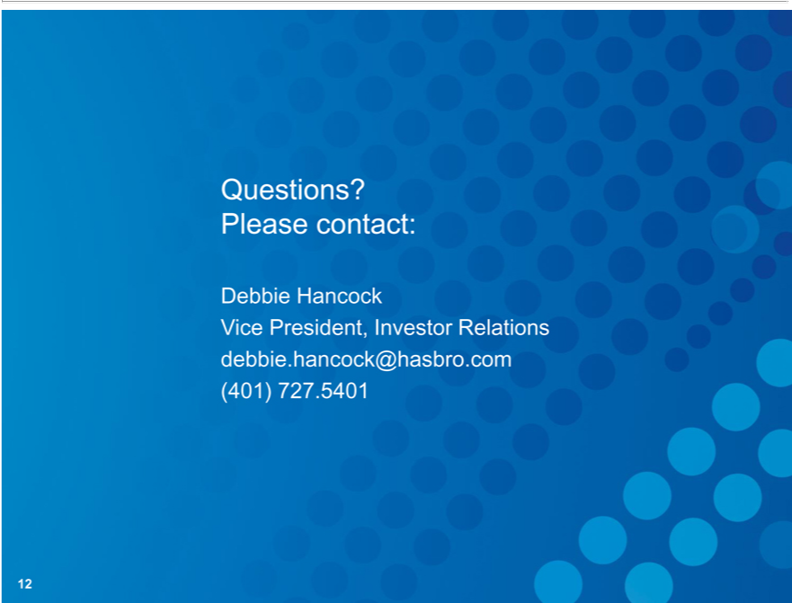

DebbieQuestions?HancockPlease contact:
Vice President, Investor Relations debbie.hancock@hasbro.com (401) 727.5401

